|  |
| --- |
| **Software Deployment v1.1** |

Prerequisites 1

Roll out software for your VM 2

# Prerequisites

Check your Software-Hardware xls created by the site surveyer, for example the Apps server of the Pinta setup:

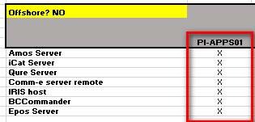

Add the VMs that need a replication number for the installation of software in the JDNNumber.txt file under \\dmm-file01\altsoftlib$\_ImportData as seen below:

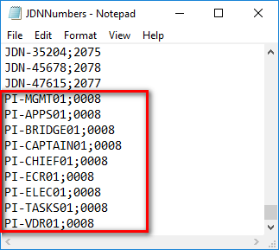

Following VMs don’t need a replication number, as they will not get their software pushed through the Altiris Agent:

* All Linux VMs
* XX-Monitor01
* XX-Backup01
* XX-File01

# Roll out software for your VM

In this example we will roll out the necessary software for the Apps server.

Go to <http://vm-alt-wf01.jandenul.com/swdeployment>

Fill in the computer name

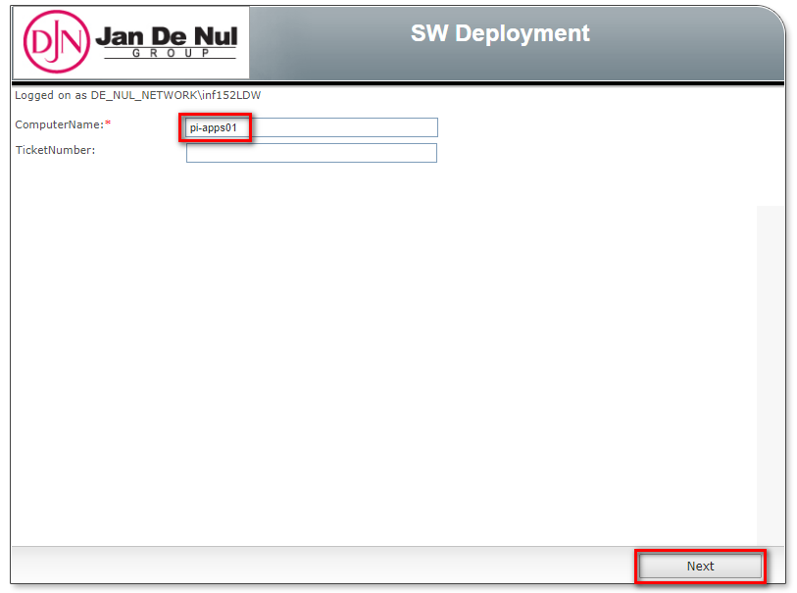

Check if your Replication Number is set correctly and press Next

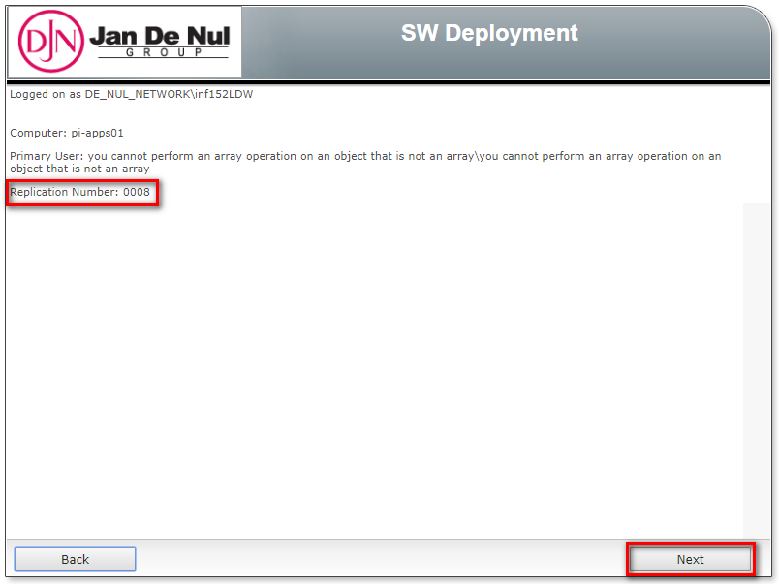

Click the checkboxes for all necessary software and click Deploy

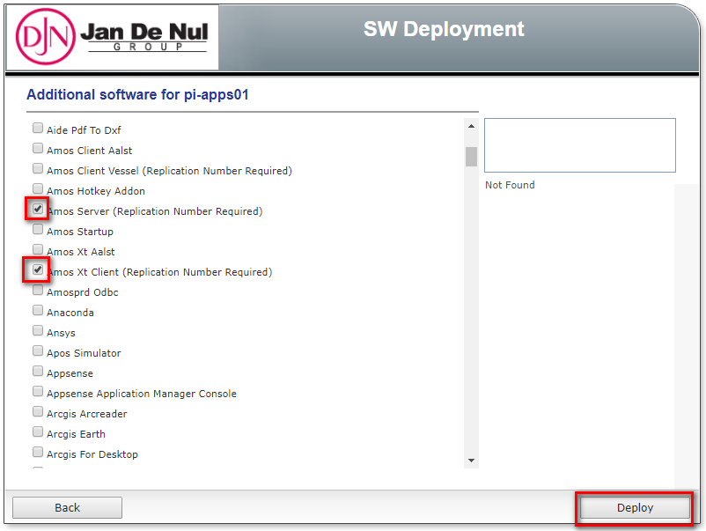

Overview the summary and click Deploy

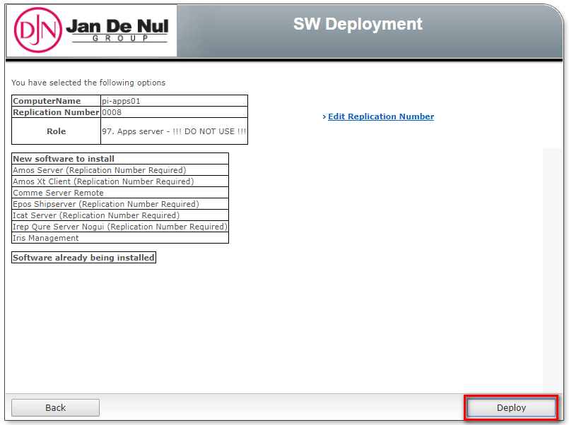

Logon to the server and wait for the requested software being installed in the Altiris Agent.

